SCIENCE FAIR PROJECT PACKET

For your use only

DO NOT TURN IN!

|  |  |  |
| --- | --- | --- |
| To Do: | Target Date: | Collected? |
| 1. Choose Topic |  |  |
| 1. Proposal |  |  |
| 1. Preliminary Research |  |  |
| 1. Identify Variables |  |  |
| 1. Research Paper / Introduction |  |  |
| 1. Procedure and materials list |  |  |
| 1. Perform Experiment and Collect Data – Take Pictures! Make Graphs and Charts |  |  |
| 1. Analysis, Conclusion, and Discussion |  |  |
| 1. Notebook and Science Fair Report |
| 1. Put Mini-Science Fair Board Together |  |  |

At the end of this project you’ll be **turning in three things**: The display board (a mini-board unless you’re selected to go to District), a Science Fair Report in a portfolio, and a Notebook. You’ll find instructions for all of these requirements in this handout.

**Keep a Notebook**

How to Keep a Notebook

* It is suggested that a composition notebook be used; spiral bound notebooks tend to be sloppy and have pages fall out.
* Make sure to write all entries in PEN.
* Write the DATE on every entry. Make sure entries are to the point and explain what you did that day.
* Don’t be too worried about neatness, it is your personal record and should not be perfect. Likewise do not scribble out incorrect information or entries; one line through the mistake is adequate.
* You should use your notebook through your ENTIRE project and write down ideas, thoughts, sources, sketches, calculations, brainstorming, notes, and anything else that could be important. Remember that this is how you will show ALL THE WORK you put into your project.
* At the end of each entry you may want to REFLECT on what went right or wrong as well as what you may want to do next time or do differently.
* Make sure you write down any changes you make to your procedure. We all make mistakes and it is good to note these as you learn from them.
* Be sure to write down ALL observations that you make during your experiment and throughout your project.
* In addition to your notebook you will also turn in a **Science Fair Report** in a thin portfolio. There you will display completed graphs, pictures of your projects, as well as other data.

Note: *If you are a Senior Fair Student and hope to continue to the International Science & Engineering Fair your notebook will be a very important part of your project. Make sure to keep accurate and informative entries throughout your project/experiment – from brainstorming to conclusions.*

1. 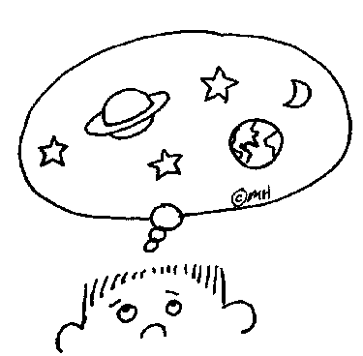CHOOSE A TOPIC

**Interests and Resources**

“Science Fair projects can be fun or

boring…it’s all in the topic you choose!”

**Interests:**

* What do you really “like” about science? Favorite activity, subjects, topics? What about other areas of science… chemistry, physics, astronomy, engineering…spark any interests!? **Be specific and try to narrow it down.**

_____________________________________________________________________________

_____________________________________________________________________________

_____________________________________________________________________________

_____________________________________________________________________________

**Consider Special Resources:**

* Special Resources are things or knowledge you already have or can get easily.

**A hobby:** Some hobbies involve special skills or equipment you may already have to help…just turn your hobby into a science fair project.

**Specialty stuff:** Do you have access to any cool or unusual materials or experts that could help? Free plants, extra electrical wire?

**A smart person:** Do you know an expert or professional that might be able to lend a hand…or an idea?

_____________________________________________________________________________

_____________________________________________________________________________

_____________________________________________________________________________

_____________________________________________________________________________

**Do an Ideas Search:**

|  |  |  |
| --- | --- | --- |
| **The Library:**  The school or local library is a science fair bonanza. You can browse books on science topics or pick up a science fair book. You can look at magazines such as National Geographic, Popular Science, Discover, and many more. | **The Internet:**  There’s enough science info on the internet to keep you reading 24/7. Use my website for additional links.  Discovery Channel (dsc.discovery.com)  Exploratorium (www.exploratorium.com)  Fact Monster (www.factmonster.com)  How Stuff Works (science.howstuffworks.com)  NASA (www.nasa.gov)  Yahoo Kids: Science (kids.yahoo.com/science) | **Your TV:**  Check out shows like Mythbusters, and tune in to channels like Discovery, the Science Channel, Animal Planet, and other science-oriented channels. They’re sure to fan your science fair flame. |

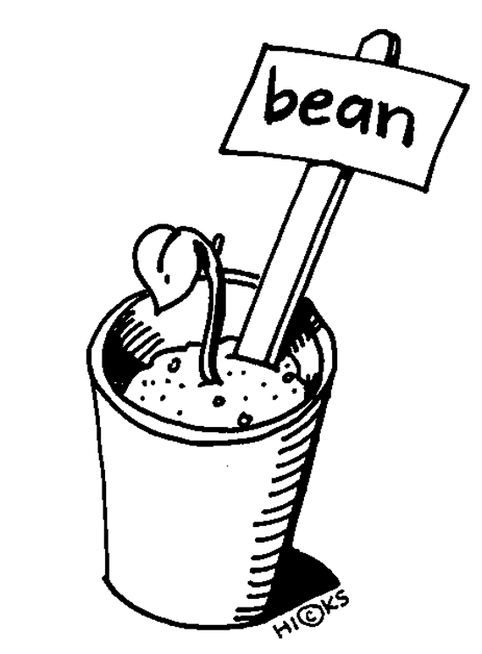**Topic Selection**

**Type of project to choose:**

* Make sure it’s a project you can TEST. It needs to have a variable that you change with intent, and produce results that you can collect data from and draw conclusions about.
* You can also choose and invention project, though it is more unusual. You’ll identify a real world problem and invent a gadget to solve that problem. Then you’ll test the invention to see how well it works.
* Avoid models (DNA, buildings, volcanoes, the solar system).
* Avoid Displays (your rock collection, leaves from your neighborhood, seashells).
* Avoid Surveys (dogs vs. cats, diet or regular, hygiene habits).

**My Topic Ideas:** (use more paper if necessary)

_____________________________________________________________________________

_____________________________________________________________________________

_____________________________________________________________________________

_____________________________________________________________________________

_____________________________________________________________________________

_____________________________________________________________________________

_____________________________________________________________________________

_____________________________________________________________________________

_____________________________________________________________________________

_____________________________________________________________________________

_____________________________________________________________________________

_____________________________________________________________________________

**Now What?**

* Now it’s time to get more specific. You need to choose your very favorite idea –the one that really knocks your socks off. You’re going to boil it down to a single question. This question will be your topic.

**The Topic is a BIG DEAL!**

* Your topic is like a springboard. It’s the starting point for the next few weeks or months of your life. So, choose wisely. Make sure your topic is something you can live with and, yes, even love!

**And the Winning TOPIC is…**

* Let’s talk for a moment about interests vs. ideas vs. topics. An interest may be very broad. An idea is narrower. A topic zooms in on one small aspect of your idea. Check out the difference in the examples below. Then try it yourself!

|  |  |  |
| --- | --- | --- |
| Examples: |  | Choose your favorites from above and try it yourself: |
| Interest: Light and heat  Idea: It’s cool that different colors absorb different amounts of heat  Topic: Which popsicle melts fastest in sunlight: red, orange or purple? |  | Interest:  Idea:  Topic: |
| Interest: Model cars  Idea: I want my models to go faster  Topic: Which lubricant works best on model car wheels? |  | Interest:  Idea:  Topic: |
| Interest: Plants  Idea: I want my garden to grow faster  Topic: Will soaking seeds first help them grow faster? |  | Interest:  Idea:  Topic: |

**Validating your Topic**

**Questions to Ask**

* Validating your topic isn’t tricky. You just have to ask the right questions. This list will help you to do it. If you answer “no” then it’s time to tweak. When you can say “yes” to everything you’re in business!

|  |  |  |
| --- | --- | --- |
| Validating question | YES | NO |
| Is there a specific answer? |  |  |
| Do I know how to find it? |  |  |
| Do I have enough time? |  |  |
| Can I get the materials I need? |  |  |
| Can I afford the materials? |  |  |
| Is it safe? |  |  |
| Is it ethical? |  |  |
| Do I understand it? |  |  |
| Is it original? |  |  |

|  |
| --- |
| Final Topic Choice: |

_____________________________________ _____________________________________ _____________________________________

_____________________________________ _____________________________________

_____________________________________ _____________________________________

You’ll be doing an assignment where you turn in your final topic choice as a PROPOSAL, so your teacher can approve it. Do **not proceed with your project until you have approval!**

1. PROPOSAL – Assignment instructions

**Problem / Question**

**Problem/Question**

* For us, the topic is also going to be the PROBLEM/QUESTION. Let’s do a final check of your Topic from above and make sure it is specific and will work. . A good question is the key to a good science fair project. Scientists ask questions and then conduct experiments to find out the answer. Therefore, the question asked should only be answered by performing an experiment, not by looking in a book.

Be specific when writing a problem. For example:

* Not specific: How do bean plants grow?
* Specific: Does the amount of water affect how tall bean plants will grow?
* Specific: Do bean plants grow better in an acidic soil or an alkaline soil?
* Specific: Does soaking bean seeds before planting them affect how fast they will grow?

**Rewrite your TOPIC here, in the form of a Problem/Question:**

_____________________________________________________________________________

_____________________________________________________________________________

_____________________________________________________________________________

_____________________________________________________________________________

_____________________________________________________________________________

**Next you do research and become educated about your topic.**

1. Preliminary RESEARCH

**What you know so far**

Directions: You must use complete sentences for full credit. You’ll want to type this information out and save it, so you can put it into your Science Fair Report later.

My Problem/Question: Rewrite your Problem below.

_____________________________________________________________________________

_____________________________________________________________________________

Prior Knowledge: What do I already know?

_____________________________________________________________________________

_____________________________________________________________________________

_____________________________________________________________________________

_____________________________________________________________________________

_____________________________________________________________________________

_____________________________________________________________________________

_____________________________________________________________________________

_____________________________________________________________________________

_____________________________________________________________________________

New Ideas to Explore: What else do I need to know about my problem? What possible new ideas could I explore about the problem?

_____________________________________________________________________________

_____________________________________________________________________________

_____________________________________________________________________________

_____________________________________________________________________________

_____________________________________________________________________________

_____________________________________________________________________________

_______________________________________________________

_______________________________________________________

_______________________________________________________

_______________________________________________________

_______________________________________________________

**Research references (sources)**

Directions: Using ideas from the previous page, research your topic using the library, internet, or other sources. While researching your topic make sure to keep a record of your resources on the following form. Again, typing all of this information will have to happen eventually, or you can do it now.

* Required Resources: 3 sources minimum; 5 recommended
* At least **1 print source** (book, encyclopedia, newspaper, magazine)
* At least **1 electronic source** (website: must be pre-approved or a .gov or .edu)
* **Student’s choice** for final source (print, electronic (.com ok) or interview)
* Possible source types: Book/Encyclopedia, Newspaper/Magazine, Website, Professional Expert
* Research Findings:

1. Source Type: ____________________________________ Title: ______________________________________________________

Date Published: ___________________________________ Pages numbers used: __________________________________

Website (if used): ____________________________________________________________________________________________

**Information Learned: ______________________________________________________________________________________**

________________________________________________________________________

________________________________________________________________________

________________________________________________________________________

________________________________________________________________________

________________________________________________________________________

________________________________________________________________________

1. Source Type: ____________________________________ Title: ______________________________________________________

Date Published: ___________________________________ Pages numbers used: __________________________________

Website (if used): ____________________________________________________________________________________________

**Information Learned: ______________________________________________________________________________________**

________________________________________________________________________

________________________________________________________________________

________________________________________________________________________

________________________________________________________________________

________________________________________________________________________

________________________________________________________________________

________________________________________________________________________

1. Source Type: ____________________________________ Title: ______________________________________________________

Date Published: ___________________________________ Pages numbers used: __________________________________

Website (if used): ____________________________________________________________________________________________

**Information Learned: ______________________________________________________________________________________**

________________________________________________________________________

________________________________________________________________________

________________________________________________________________________

________________________________________________________________________

________________________________________________________________________

________________________________________________________________________

________________________________________________________________________

________________________________________________________________________

\*\**If you have additional references or need more space write them in your Science Fair Notebook.\*\**

**Problem / Question Revision**

**Problem/Question**

* Now that you have researched your PROBLEM/QUESTION, you may want to revise it to reflect how much you know. You may revise it a little, a lot, or not at all. If your problem/questions changes much, you’ll want to get teacher approval again.

**Rewrite your TOPIC here, in the form of a Problem/Question:**

_____________________________________________________________________________

_____________________________________________________________________________

_____________________________________________________________________________

_____________________________________________________________________________

_____________________________________________________________________________

1. Identify VARIABLES

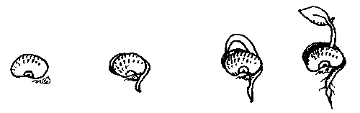**hypothesis**

**Hypothesis:**

* The **Hypothesis** is another name for a prediction or **an educated guess**. When you are writing the hypothesis you are trying to predict the answer to your problem. You should always give a **reason for your hypothesis**, either from your own experiences or from research you have done. For full credit you should also provide the scientific background for how you arrived at your hypothesis and refer to your research. When it makes sense, turn it into an “If…, then…, because…, research shows” statement. For example:

Problem: Does soaking the bean seed before planting it affect how fast it will grow?

* Possible Hypothesis: I think that bean plants that have their seeds soaked before planting will germinate faster because it will make the hard seed covering soft. “If…, then…, because…, research shows” statement: If I soak beans before planting them then they will germinate faster because it will make the hard seed covering soft. Also my research shows that seeds require water for them to sprout.
* Possible Hypothesis: I do not think that soaking the beans will make the bean plant germinate faster because soaking the seed will just make the seed mushy. “If…, then…, because…, research shows” statement: If I soak beans before planting them then the will not germinate faster because it will make the seed mushy. My research shows that plants exposed to water too long can rot and die.

**Your Hypothesis with the “because and research”:**

* **Your hypothesis will actual be 3-5 sentences because it must reference your background research. Here are some sentence starters to get you going…**

|  |  |
| --- | --- |
| **First, your prediction and why you think it will happen**   * If… Then… * I think… because… * I predict that... Because… * Based on my observations…. I infer... | **Next, reference your research**   * In my research I learned… * According to (reference here)… * Using different resources such as… I found… |

**Write your hypothesis here:**

_____________________________________________________________________________

_____________________________________________________________________________

_____________________________________________________________________________

_____________________________________________________________________________

_____________________________________________________________________________

_____________________________________________________________________________

_____________________________________________________________________________

_____________________________________________________________________________

**Variables**

Take time to identify your variables before you start your experiment. It will help you to write your procedures. A **variable** is something that can change or be changed. There are three kinds of *variables:* independent, dependent and controlled variables.

* **Independent Variable (Manipulated Variable):**

In a well-designed investigation, there should be only **one** thing changed on purpose, called the independent variable (or manipulated variable).

Remember the example problem: Does soaking the bean seed before planting it affect how fast it will grow?

In this example, the thing I am changing on purpose is soaking some of the bean seeds before planting them. Therefore, the soaking of the seeds before planting is the independent variable. You should do several test amounts (like soaking one seed for 3 hours, one seed for 6 hours, one seed for 24 hours, etc.). And you should do several trails (run the test again – five trials is usually the standard).

* **Dependent Variable (Responding Variable):**

What I think or hope will change during the experiment is called the dependent variable (or responding variable). This variable is “dependent” on the one you change. You will measure this change, and call it your “data.”

In this example the thing I am hoping or thinking will change during the experiment is how fast the plant grows. Therefore, I would record how many days it took to germinate, and then measure growth in centimeters each day. Plant growth is the dependent variable.

* **Controlled Variables (Constants):**

To make sure that your experiment is not influenced by anything other than the one thing you are testing (independent variable), it is important to keep ALL other things that might e changed the same throughout the experiment. The things that are kept the same are called the controlled variables (or constants).

In this example the things I would keep the same are: the type and size of the bean, the amount of water for soaking the seeds, the type of soil I plant the beans in, the amount of soil I plant the beans in, the amount of water and sunlight they get every day, the size of containers I plant the beans in, the temperature. These are the variables I am controlling.

* **The Control (the control group)** is not a variable. It is one of your trials that gets a normal amount or none of the independent variable. It is what you use as your standard of comparison so see if your independent variable has any effect. Not all experiments need a control, but you should have one if it makes sense.
* **The Experimental group** is not a variable. It is one or more of your trials that get varying amounts of your independent variable.

|  |  |  |
| --- | --- | --- |
| What makes a good variable? | YES | NO |
| Is the independent variable measurable? |  |  |
| Can you change the amount or quality of the independent variable? |  |  |
| Have you identified all relevant dependent variables and are they all caused by and dependent on the independent variable? |  |  |
| Are all dependent variable(s) measurable? |  |  |
| Have you identified all relevant controlled variables? |  |  |
| Can all controlled variables be held at a steady value during the experiment? |  |  |
| Can you repeat the test? |  |  |

What makes good variables?

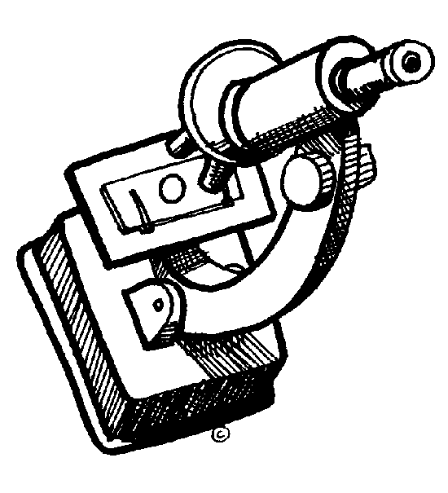For good variables, you should answer “yes” to every question to the right.

|  |
| --- |
| **Identify your Variables**  Independent Variable (What I will change on purpose): ________________________________________________________  ________________________________________________________________________________________________________________________  ________________________________________________________________________________________________________________________  Dependent Variable (What I think will change during the experiment): ______________________________________  ________________________________________________________________________________________________________________________  ________________________________________________________________________________________________________________________  Controlled Variables (What I will keep the same): ______________________________________________________________  ________________________________________________________________________________________________________________________  ________________________________________________________________________________________________________________________  ________________________________________________________________________________________________________________________  Control Group (The experimental group that gets “normal amount” or none of the independent variable): ___________________________________________________________________________________________________________  ________________________________________________________________________________________________________________________  ________________________________________________________________________________________________________________________  ________________________________________________________________________________________________________________________  ________________________________________________________________________________________________________________________ |

1. C:\Program Files\Microsoft Office\MEDIA\CAGCAT10\j0195384.wmfWrite your research paper / Introduction

Your research will be incorporated into your INTRODUCTION in your SCIENCE FAIR REPORT. You can use the same sources you found earlier in this packet when you did your PRELIMINARY RESEARCH, or you can use others.

In your SCIENCE FAIR REPORT, your introduction is a 2-3 page mini research paper. Its purpose is to provide background information on your topic in order to explain the purpose of your experiment.

Your introduction is based on your research notes. You may also include your own observations on the topic.

Wherever you use facts or ideas from another author, cite your references in your report using MLA-style parenthetical citation.

Start your introduction with general ideas about your topic and move to more specific details.

Your entire report should be written in third person point of view.

In the last paragraph of your introduction,

1. Clearly state the problem/ question you decided to investigate.
2. Briefly describe your experiment’s procedure.
3. Conclude by stating your hypothesis. Write this paragraph in past tense.

Things to consider when writing your Introduction:

|  |
| --- |
| **Content** |
| * Have you introduced your research question or topic? |
| * Have you included a history of important discoveries, experiments and findings? |
| * Have you included famous scientists who have contributed to this topic? |
| * Have you defined all important terms and definitions? |
| * Have you included a conclusion about what was learned through the research? |
| **Format** |
| * Is your paper separated into distinct sections (topic, history, terms, etc. . . )? |
| * Do you have proper MLA citations for each quote/fact/picture you use? |
| * Do you have a “Works Cited” list using proper MLA citations? |
| **Editing** |
| * Have you used proper capitalization and punctuation? |
| * Have you double checked your grammar and spelling? |



Check out the example of an INTRODUCTION your SCIENCE FAIR REPORT handout!

1. Procedures and Materials List

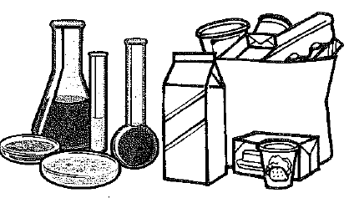

**Materials:**

Your materials is a list of all of the items you will need in order to conduct your experiment. As you develop your procedure, you may need to add to your materials list.

Remember to:

Be specific

Give amounts and sizes

Use METRIC measurements

It’s also a good idea to take pictures of your materials. This could come in handy when you are making your Science Fair Display Board. Oh, and don’t forget you can ask to use equipment from Mrs. DeCaire!

|  |
| --- |
| **Materials** |

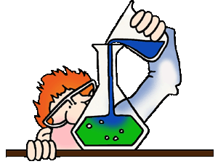**procedure:**

Procedures are a detailed step by step set of directions of how to conduct the experiment. Details are very important here. Be sure to tell exact amounts (use the metric system) of things such as materials, time it will take, etc. It is important that anyone be able to follow your steps and repeat your experiment exactly as you did it. You must have at least 3 repeated trials (5 repeated trials the standard) and clearly identify what you are keeping the same and what you are changing to ensure a well-designed investigation.

Take pictures of your procedural set up, or make a drawing if necessary to help others understand what you did. Label all parts and provide a title.

Good procedures are easy to follow, and numbered to be sure they are done in the correct order.

Example:

1. Put two identical bowls on the counter.
2. Take two ice cubes of the same size out of the freezer and place one in each bowl.
3. Break one of the cubes into smaller pieces that are no larger than ¼ the size of the whole ice cube.
4. Time how long it takes for all the ice to melt.

A good way to check the procedure is to ask someone else to read it, and then have them explain how the experiment is to be done. If they explain it wrong or have difficulty, your procedures may need to be revised.

|  |
| --- |
| **Procedure** Use more paper if you need more space!  "Bunsen's Burner, a form of gas burner especially adapted for heating, consisting of a tube, in which, by means of holes in the side, the gas becomes mixed with air before consumption, so that it gives a non-illuminating smokeless flame." -Vaughan, 1906 |

1. Perform your Experiment and Collect Data

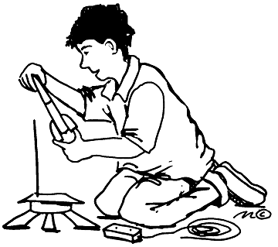**TEST, TEST, TEST!**

Remember that the judges expect your results to be consistent in order to be a good experiment, in other words, when you cook from a recipe you expect the outcomes to be the same if you followed the directions (or procedure) step by step. So that means you need to do the experiment more than once in order to test it properly. We recommend five times or more. More is better!

Don’t forget to take pictures of the science project being done and the results.

**Data Collection**

Write down or record the results of the experiment every time you test it. Be sure to organize it in a way that is easy to read the results. Most scientist use tables, graphs and other organizers to show their results. Organizing makes the results easy to read, and much easier to recognize patterns that might be occurring in your results. You should also make journal entries in your Notebook while conducting the experiment. Notes may be brief but should be very descriptive. Always include the date for each entry.

|  |
| --- |
| **Notes on Data Collection…**   * **Keep a Notebook:** Your Notebook is like a science diary. It is especially useful if your experiment takes place over a long period of time. Date each entry and record your observations, draw and diagram pictures and jot down any questions you might have for later. Data collection should be done by hand in your notebook and then transferred into a computer generated graph for presentation on your Display Board. * **Have the right tools to do the job:** Make sure you have the stuff you need to take accurate measurements like rulers, meter tapes, thermometers, graduated cylinders or measuring cups that measure volume. The standard of measurement in science is metric, so if your measurement tool isn’t in metrics, you’ll need to make conversions (there are many websites that can help you). * **Two types of data:** Quantitative data is numerical data and should be displayed in a chart or graph. Qualitative data is descriptive data (such as color, texture, odor, etc.) and should be put in a chart. You can convert qualitative data into quantitative data by putting it on a scale (ex. Dark green = 10, Medium green = 5, Light green = 1) and then your can display it in a graph. * **Be accurate and neat!** When you are writing your tables and charts please make sure that you record your data in the correct column or row, that you write neatly, and most of all that you record your data as soon as you collect it **SO YOU DON’T FORGET WHAT HAPPENED!** Sometimes an experiment might be hard to explain with just a table, so if you have to draw and label a diagram (or picture) to explain what happened, it is recommended that you do. Pictures can also help make things more clear. |
| **Data on your science fair board** |
| **Data presentation**   * **Visual data display:** Tables, charts and diagrams are generally the way a good scientist keeps track of experiment trials. Remember to test 5 times or more. A table is organized in columns and rows and ALWAYS has labels or headings telling what the columns or rows mean. You will probably need a row for every time you did the experiment and a column telling what the independent variable was (what you tested), and the responding variable was (the result that happened because of the independent variable). * **Use the right graph for your experiment**. There is nothing worse than a bad graph. There are all types of graph designs, but these seem to be easy to use for science fair experiments.   + **Pie graphs** are good to use if you are showing percentages of groups. Remember that you can’t have more than 100% and all the pieces need to add up to 100%. This type of graph is great if you are doing surveys.   + **Bar graphs** are good to use if you are comparing amounts of things because the bars show those amounts in an easy to read way. This way the judges will be able to tell your results at a glance. Usually the bars go up and down. The x axis (or horizontal axis) is where you label the group names and the y axis (or vertical axis) is labeled to show the amount that was measured and units (in this case it would be centimeters that the plant grew).   + **Line graphs** are good to use if you are showing how changes occurred in your experiments over time. Experiments that have dependent variables that involve temperature, height or distance changes over time are commonly graphed using line graphs. For example, you would use the x axis to show the time increments (minutes, hours, days, weeks, months) and you would use the Y axis to show what you were measuring at that point in time (temperature, height, distance, length, mass). * **Label everything!** You should have a TITLE for every graph or chart, and both the X and Y axes need to be LABELED, saying what data is being displayed, and what UNITS it is in. * **Computer graphs:** Be extra careful when using a computer to create your graphs. The computer will create any graph you want, whether it is the correct graph or not. Also, many computer graphs leave off important titles and labels. Check and double check any graph you make on a computer. * **Need help?** Make sure you ASK if you need help with how to display your data. Judges will be sure to look for the quality of your data display, and it can make or break your Science Fair Board presentation. |

1. Results, Conclusion & Discussion

**Results – what does your data say?**



Though visually displaying your data in a graph or chart is nearly mandatory for science fair, they can leave questions for the observer if they appear without an explanation. The explanation of your data is called your Results. All results should include three parts:

1. Visual Data Display (charts, graphs, tables)
2. Written explanation of the data
3. Photographs and/or diagrams to help the viewer understand the data

In the written explanation of the data, describe to the observer what your data means. If you used any statistical methods, you should describe why – did you use the mean, median or mode? Why does it make sense to do these calculations? Describe any trends that may occur in the data, or anything unexpected, or any outliers (numbers that deviate a great deal from your other data). Here are some questions to ask yourself as you write.

1. What do your overall results show?
2. What does your chart and/or pictures show? What is the trend?
3. What does your graph show? What type of graph is it? What is the overall result? How did each trial compare?

This should be in paragraph form (minimum 4-5 sentences) with an introductory sentence (a), body sentences (b-c), and a conclusion sentence that sums up what you talked about. It can be longer if necessary.

**Conclusion – How do your results compare to your hypothesis?**

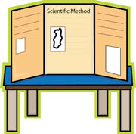

Your conclusion should compare your data and results to your initial hypothesis. This is where you discuss what you learned about the topic by completing your experiment. Here are some questions to ask yourself as you write your conclusion.

1. Was your hypothesis supported by the data or not supported? (My hypothesis was… and I predicted that… The data supports/does not support… NEVER say your hypothesis was “correct”.)
2. What is the answer to your topic question? Support your answer with the data collected. (I was trying to find out… and learned that… My data showed… The overall results…)

This should be in paragraph form (minimum 4-5 sentences) with an introductory sentence (a), body sentences (b-c), and a conclusion sentence that sums up what you talked about. It can be longer if necessary.

**Discussion – So what does it all mean?**

The discussion portion of your Science Fair Board shows observers that you have thought about the implications of your experiment. Here are some questions to ask yourself as you write your discussion.

1. 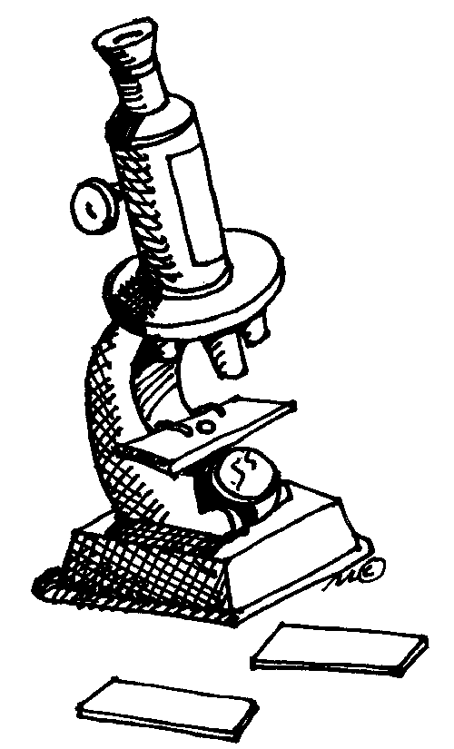Was there anything that surprised you?
2. Was there anything that you couldn’t have predicted?
3. Evaluate your experimental procedure, making comments about is successes or failures.
4. Were there any problems with the investigation or things you would do differently? (I think the results were inaccurate because… If I were going to do this experiment again I would…)
5. Does it spark any inspiration for future experiments?

This should be in paragraph form (minimum 4-5 sentences) with an introductory sentence (a), body sentences (b-c), and a conclusion sentence that sums up what you talked about. It can be longer if necessary.

**Application – What can I do with this in the real world?**

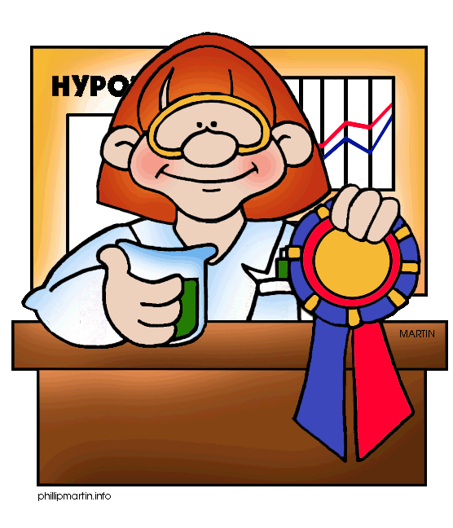

The application portion discusses how your science project could help someone in a real life situation. For example, a simple science project like which paper towel brand is stronger, the application for this project could be "If someone in the world wanted to soak up more with a paper towel, then that person could use 'this' brand instead of 'this' one because the other towel brand is stronger and soaks up more liquids. Consider these questions as you write the application portion of your science fair display.

1. 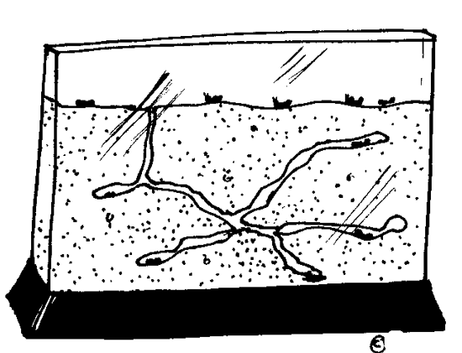Based on your results, could you make a recommendation to people?
2. Is there an application in industry for this knowledge or a commercial application?
3. Could a scientist doing similar studies use your techniques or process?
4. Could your results be used in the future?

If you can’t think of a practical application, it is better to leave this part off instead of writing something that makes no sense. Good application will impress the judges!